

**CLOUD COMPUTING**

**Name: Tooba Shafique**

**Section: BSE-V-B**

**Reg no: 2023-BSE-065**

**Assignment -01**

**Task 1**

* Screenshot of your Gitea repository (showing README listing names & roll numbers)
* I added names in gitea remotely.

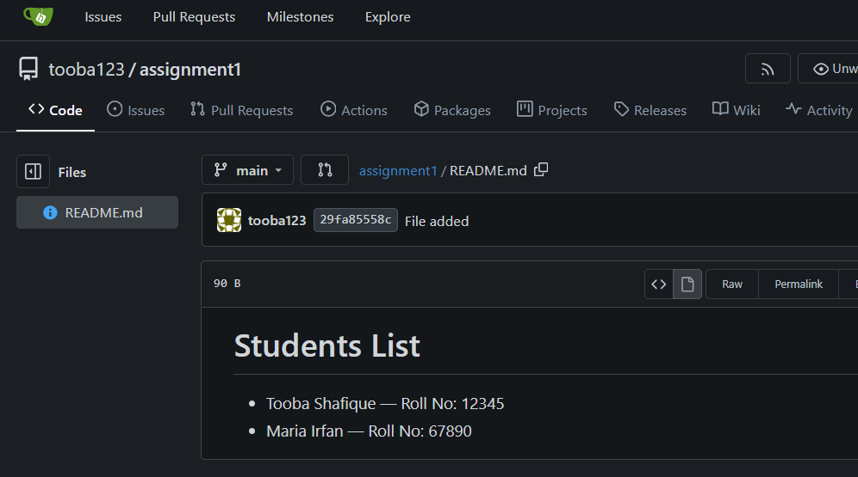

* After connecting Gitea codespace with gitbash I added another student’s role number in README.md and pushed in Giteau repo.

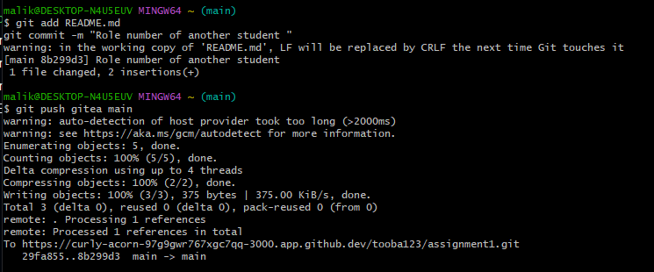

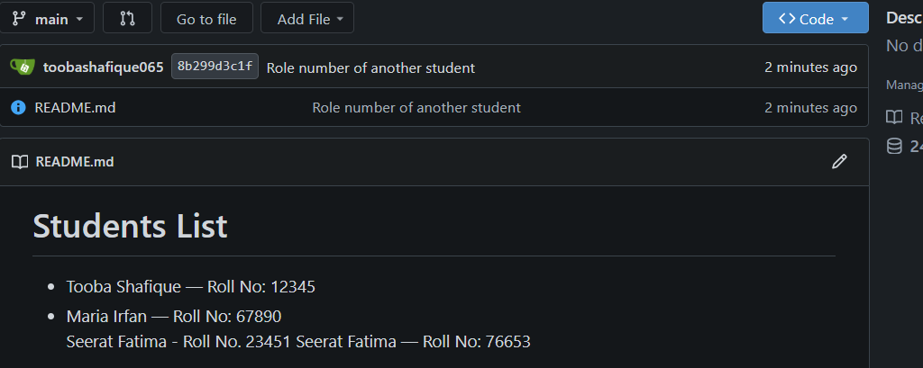

**Task 2**

* GitHub assignment 1 repo link (with README and large files)

Repo link: <https://github.com/toobashafique065/assignment1>

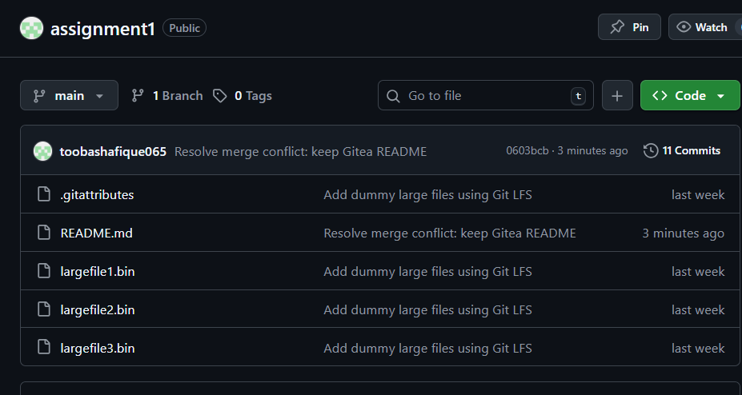

**Task 3**

* Screenshot or output of git remote -v showing both remotes

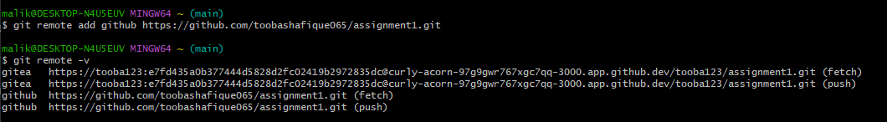

**Task 4**

* Screenshot of GitHub Pages link to your CV/portfolio

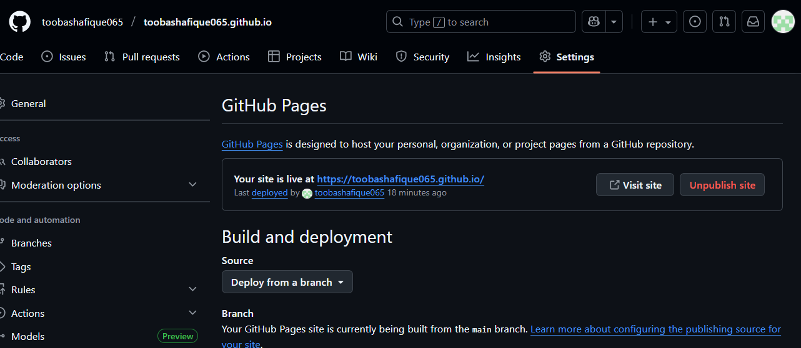

* Link of CV: [**https://toobashafique065.github.io/**](https://toobashafique065.github.io/)

===========================================================================